To resolve acess denied iss ueh t the monitoring `monitoring.ui.ccs.enabled` is set to `true`

I saw this issue when setting up the multi cluster and click on stack monitoring page.

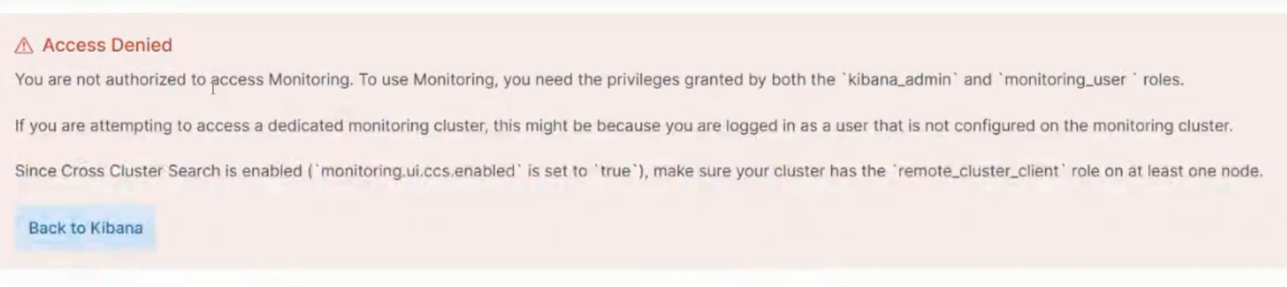



First search for it if it is existing within the kibana.yml file, if not then add it towards the end of the file.

Second thing you need to make sure: Let’s suppose your cluster is down and there are index still lingering around. You will have to delete them or back them up because the shards are missing/unassigned shards. You can do this from the api as well. So if the shards are unassigned, then you can delete and re-index to make the shard assigned.A screenshot of a computer

We can also identify which shards is missing through the api and then granularly delete those